**CS273 ASSIGNMENT #5: Object-Oriented Design - Inheritance and Polymorphism**

## Name: _____ .

**Grade:**

|  |  |  |
| --- | --- | --- |
| **CATEGORY** | **POINTS** |  |
| PR5_Banking: Part 1 – **Design Document**  **(Please read the Heads-up Below!)** |  | 50 |
| **TOTAL** |  | 50 |

**Objectives:**

* Apply the concepts of information hiding, inheritance, and polymorphism.
* **Practice building moderately complex software from a software specification**. This is much harder than you would think, and we can only get better if we practice doing this.

**Design Project (this is part 1 of 2 parts to this problem)**

Create a repository on Github for this project

* Carefully read programming project 4 on page 227
* **Do not start implementing the banking program yet.** Your implementation is not due until the next assignment (assignment #5).

For this exercise, imagine you are in a software company, and you have been given this problem specification. The class interface defined needs to be strictly followed because of external dependencies with other software components. Other software groups depend on you to accurately following the defined classes. **Furthermore, much of the code has already been written by other members of your team.** **Your job for this assignment is to understand the design requirements, and complete the implementation.**

**Design Document Requirements**

Study the problem description and the code we have given you as a starting point, banking.zip on the class folder. You will need to develop the following items:

1. **(10 pts) A** **requirements specification** of the software that needs to be created in your own words. This should be a short English narrative describing **what** **you** **think** **the** **software** **should** **do and what it will operated like**, **not how it will implement** its functions.
2. **(10 pts)** Detailed **use cases** for **all** **the scenarios** you imagine the software will be used. Look at the phone directory example in the text book (**section 1.5**) to guide you with this.
3. **(10 pts) UML diagrams** to describe the **relationship between the classes** described in the problem. **You do not need to describe any sequence diagrams unless you wish too**.
4. **(10 pts) Pseudocode (**see page 106 in your book for an example**)** to describe how the following methods will be implemented. Note, you will need to implement more code than is described here…

* **Add**_**Account in Banking_Application.cpp**,
* **make_deposit() methods in Bank.h and Banking**_**Application.cpp,**
* **make_withdrawal() in Banking**_**Application.cpp**
* **Overloaded** **add_account() methods in Bank.h**
* **get_account()** in the **Bank.h**

1. **(10 pts) Bank Data Storage Description** – A description of HOW the account numbers for accounts and the customer id numbers will be generated and stored. How will accounts be linked to customers? How will transactions be linked to customers? (see **Bank.h**)

Please use all the design tools we have discussed in the Phone Directory example (pages 102-121). You will need to extend the design by **incorporating other properties (member variables) and methods**, but your final design must include the classes and methods described in the problem.

**At the end of this exercise, you should feel a little bit more confident in implementing the solution to this problem. Talk to other classmates about your design, go back to your design, and address any doubts you might have. Ask questions.**

**Additional information for programming project 4 on page 227**

* **Class Account Correction**: The data field **customer** should be of type **Customer*.**
* Please use the project in **the class folder** as a starting point.
* We have written a significant amount of code for you. However, understanding what we have done and what you need to do will be challenging. You need to study the code and problem description carefully to understand what will need to be done to complete the implementation.
* The **Transaction Class**  has already been implemented for you.
* The project already has a **main()**function that servers as a menu and calls the described methods of **class** **Bank** as appropriate to implement your banking program. **You may need to add features to this depending on what use cases and additional features you decide to implement**.
* Complete the design (and later the implementation) for **classes** **Account, SavingAccount, CheckingAccount, Customer, Senior, Adult, Student, and Bank**.
* NOTE: As stated earlier, the **class Bank** has overloaded the **add_account** method. Please work to understand how these will be used from reading the starting code I have provided, and your **Use Cases**.

**!!! Major “Heads Up” for this and the next assignment**

* This is a large project and you absolutely won’t be able to finish it if you start the night before it is due.
* **Plan on a minimum of 6-8 hours or more for completing both assignments 5 and 6.**
* **Design and implementation often go hand-in-hand**. So please look at the starting code now, to understand how your design is going to co-exist with the current implementation.
* **When you are stuck, use the Visual Studio Debugger**. I have included a simple tutorial in this document that shows you how to use the debugger to understand what your code is doing.

## Using the Visual Studio Debugger

Let us begin with a simple example. I have the following code in Visual Studio. The code implements a simple **swap()** function (you know the one we learned about in CS-171).

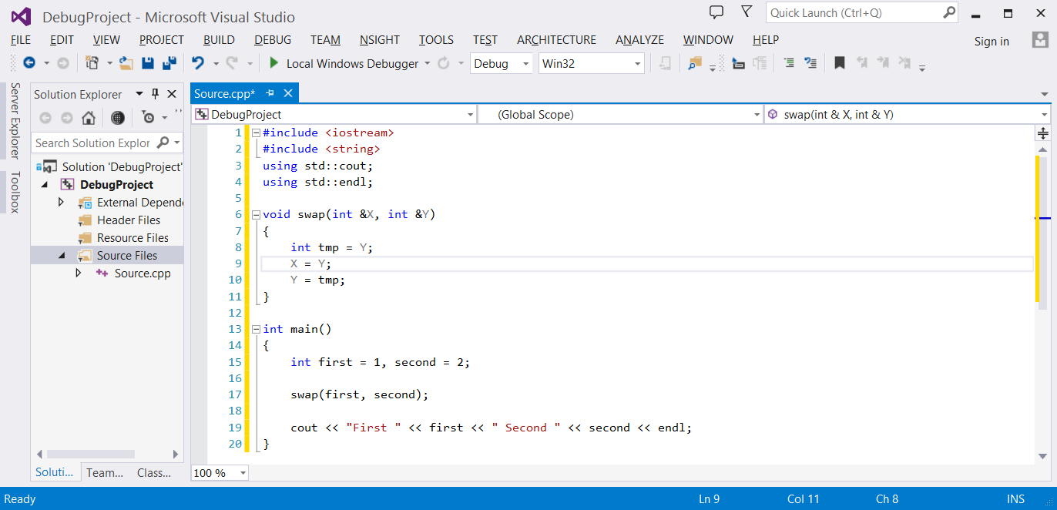

Unfortunately there is a bug in this code, because when I run it, the output is

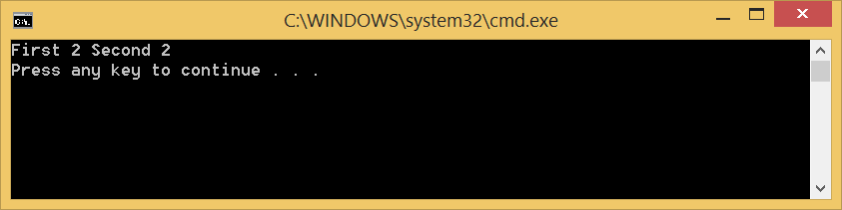

To help me understand what is going on in this program, I will use the debugger to examine the state of the program while it is running.

The first thing I will do is add a **breakpoint** in the code. A **breakpoint** is a location in the code I wish to examine when the program is running. Basically, the **breakpoint** will cause the debugger to automatically stop the program at that point when it executes.

To add a **breakpoint** in Visual Studio, I will move my mouse pointer to the location of the code I wish to examine, and click on the left gray border in the code editor window. The **breakpoint** will appear as a red dot in the gray border.

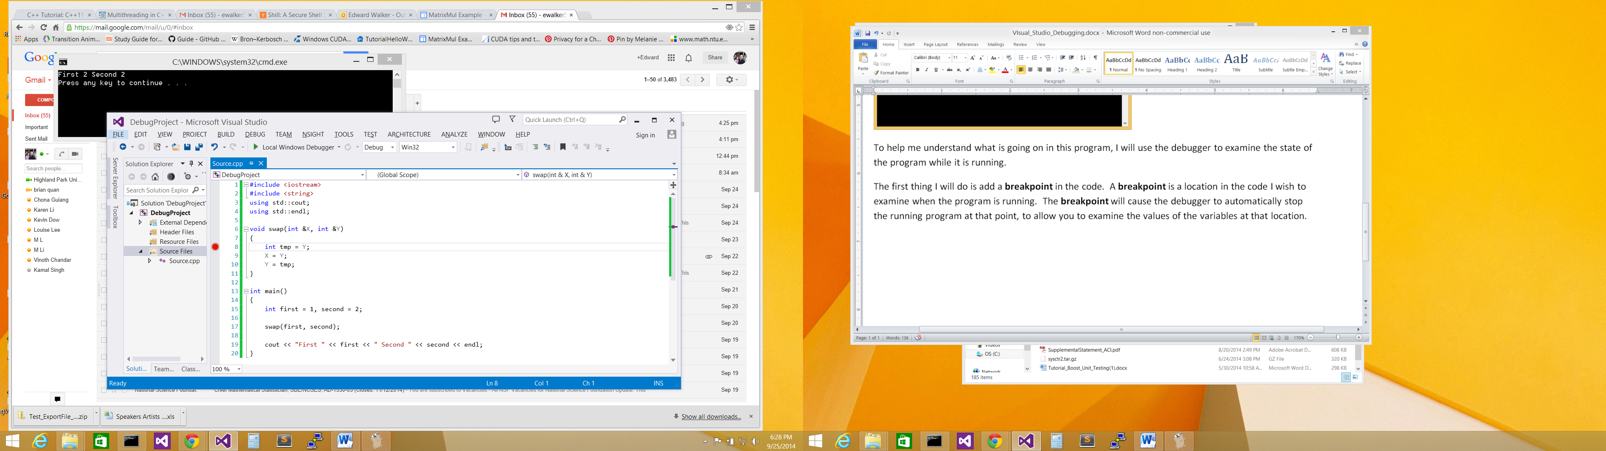

Click on border to add a **breakpoint**

Now I will ask Visual Studios to run my program until it reaches this **breakpoint**. To do this, I will select the **Start Debugging** option from the **DEBUG** menu.

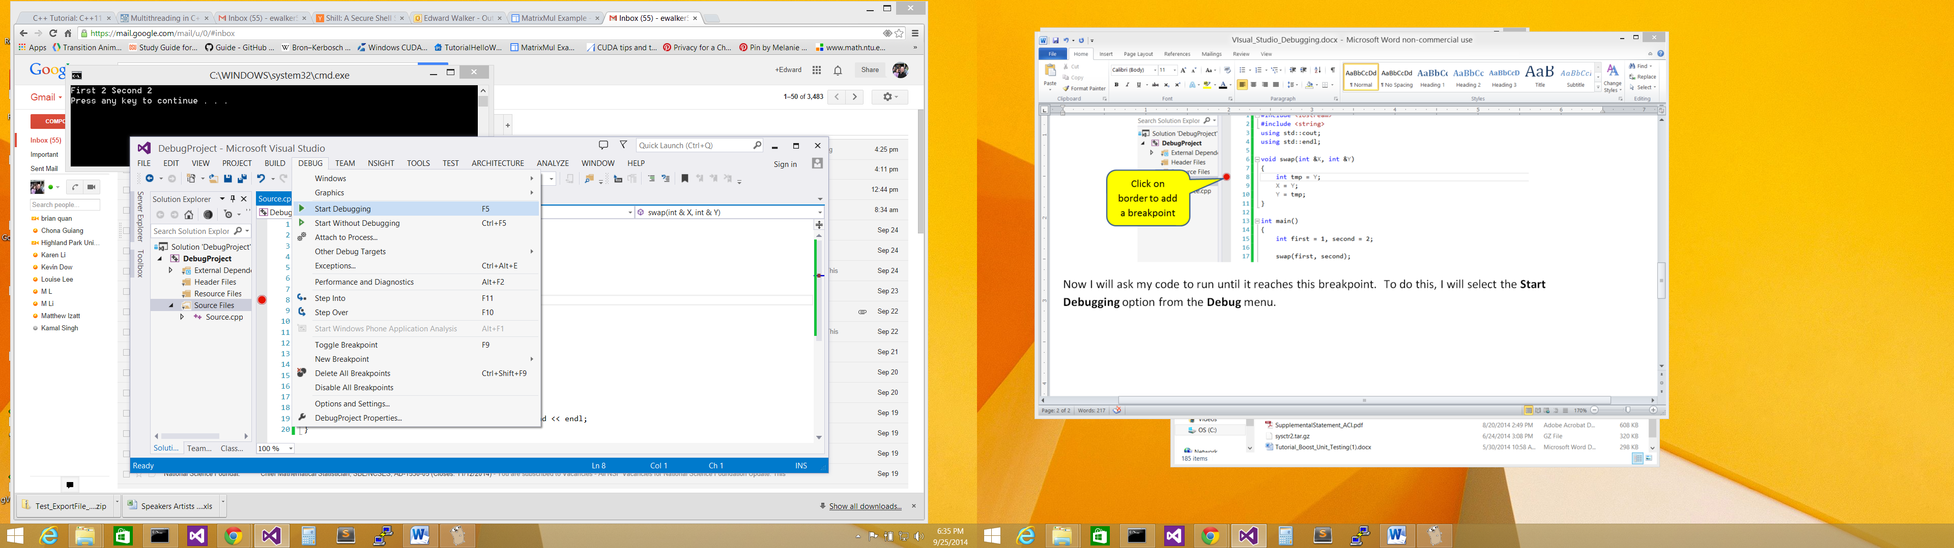

Select **Start Debugging**

This will cause my program to run until the breakpoint is encountered. Visual Studios will pause the program at the **breakpoint** to allow me to examine it. Pretty neat huh! Visual Studios will also indicate where it is currently at in the executing program with a yellow arrow on the left gray border of the code editor window.

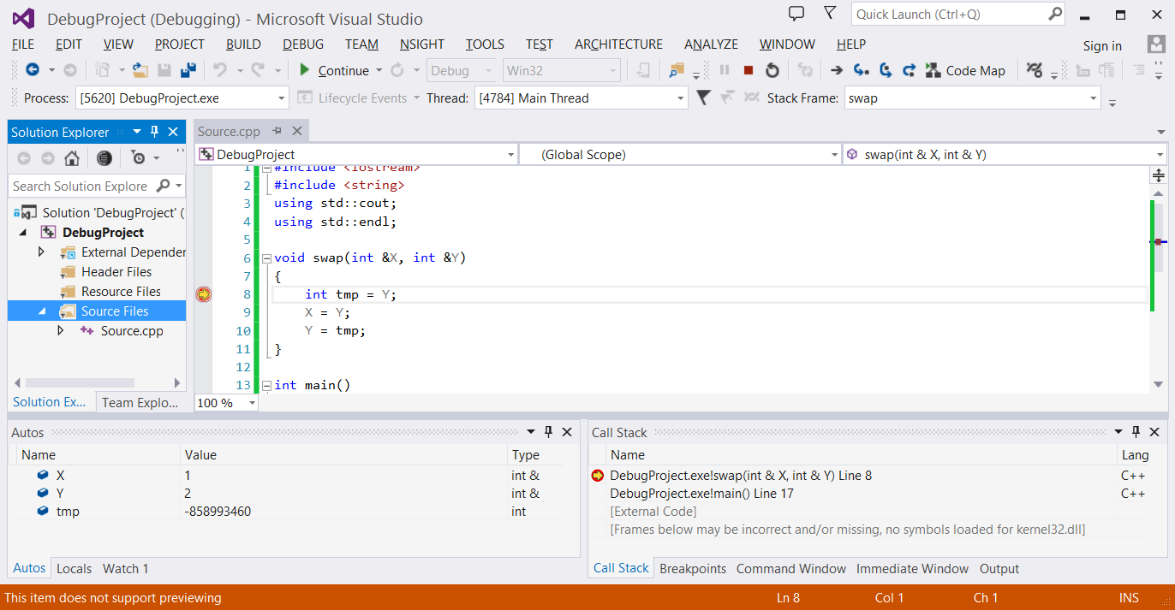

**Yellow arrow** indicates where the executing program is at!

By hovering over any of my variables, I will be able to see their values now. For example,

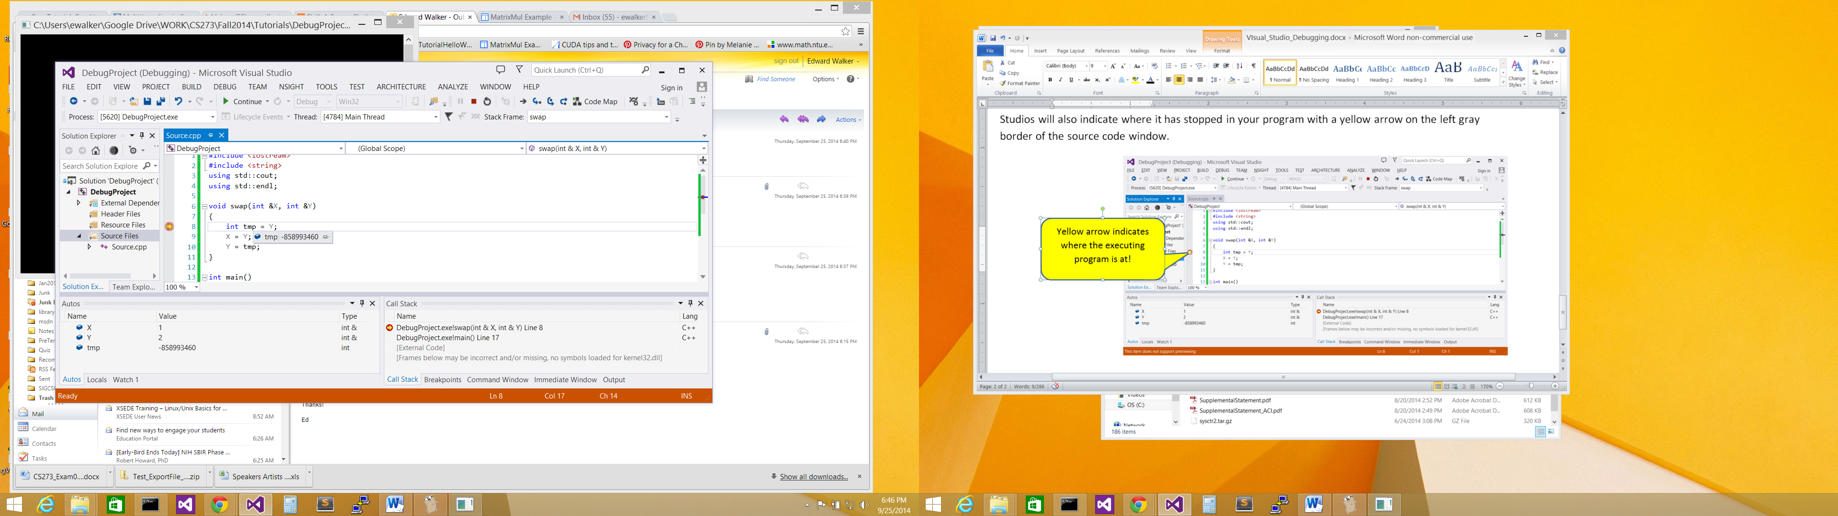

I see that variable **tmp** does not have a sensible value assigned to it yet, because the assignment statement has not been executed. If I hover over variable **Y**, it will show me that it has the value **2.**

I can also examine all the local variables in the **swap()** function by looking at the **Autos** window.

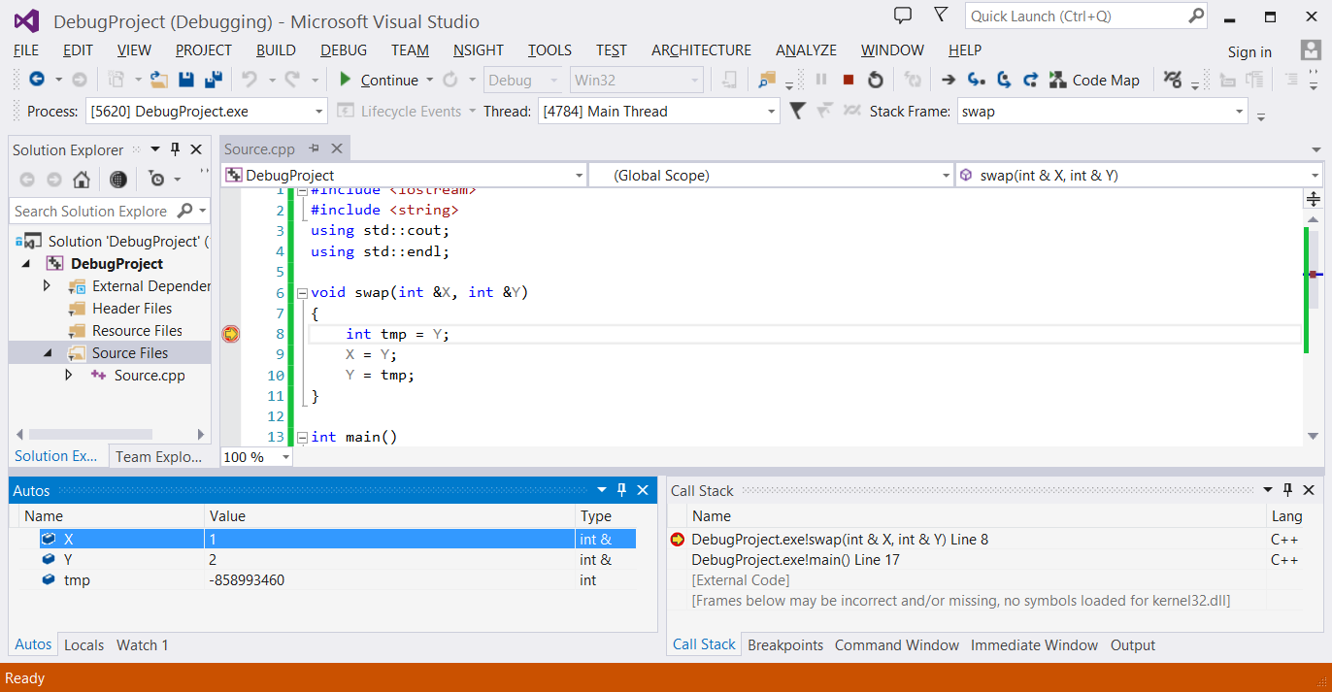

If I do not see this window, I can always open it by selecting the **Windows** **🡪 Autos** option from the **DEBUG** menu as shown below.

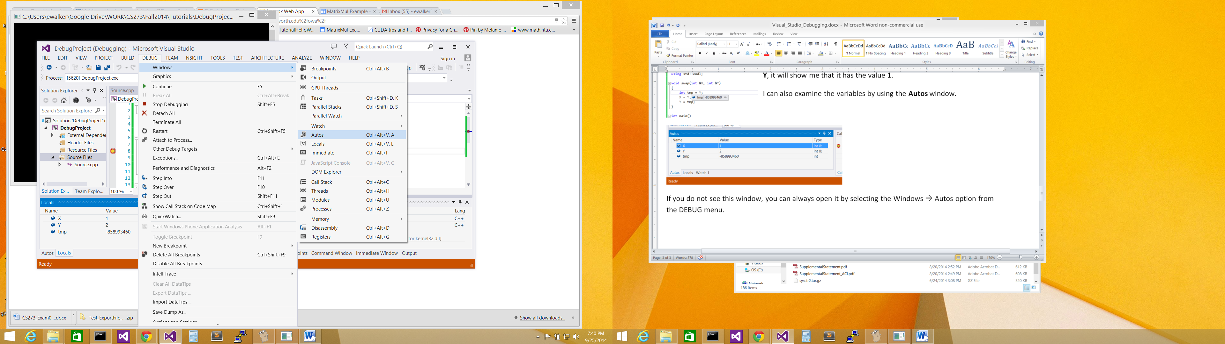

Select this to open the **Autos** window if it is not already open.

Now if I wish to step through my program, i.e. execute one statement at a time to see how my program is behaving, I will need to click on either the **Step Into** or **Step Over** button.

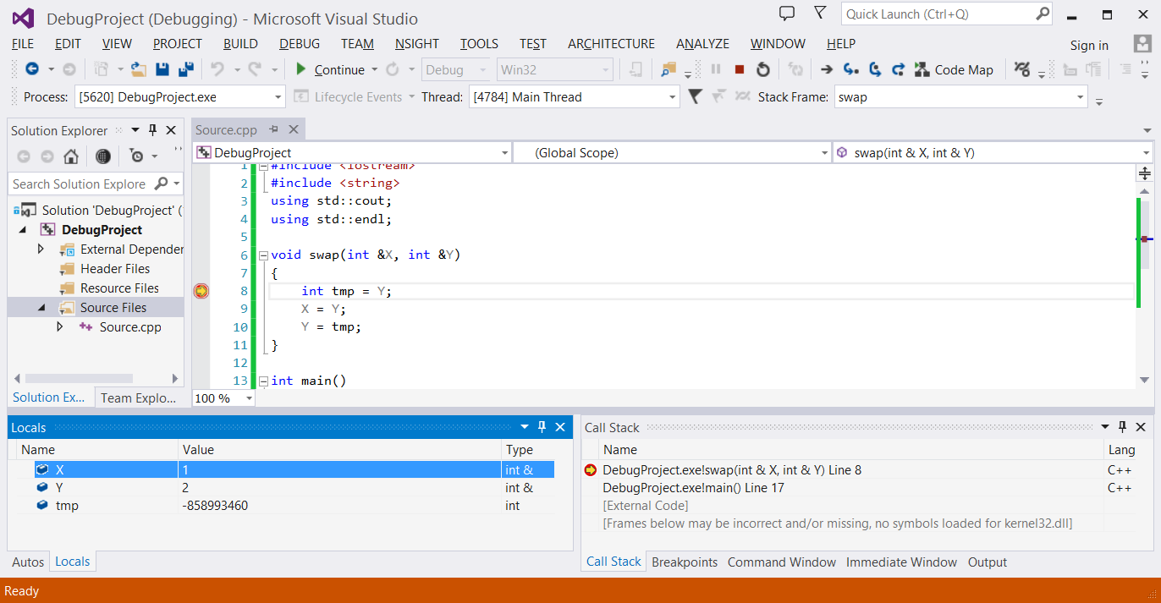

**Stop Debugging**

**Step Into**

**Step Over**

**Step Into** and **Step Over** both executes ONE line of code, but each will behave differently depending on whether there is a function being executed at that line. **Step Into** allows you to step into the function to see the next line of code in the function that will be executed. However, **Step Over** will execute the function in its entirety and move to the next line of code after your breakpoint. Because my code is not executing a function in the assignment statement I am currently at in Visual Studios, I can pick either **Step Into** or **Step Over**.

I will select to click the **Step Over** button. This will cause the assignment statement to be executed. Looking at the **Autos** window, I will see that the variable **tmp** will now have a new value of 2. I will also see that Visual Studio has highlighted the value change in the variable **tmp** by changing its color to red.

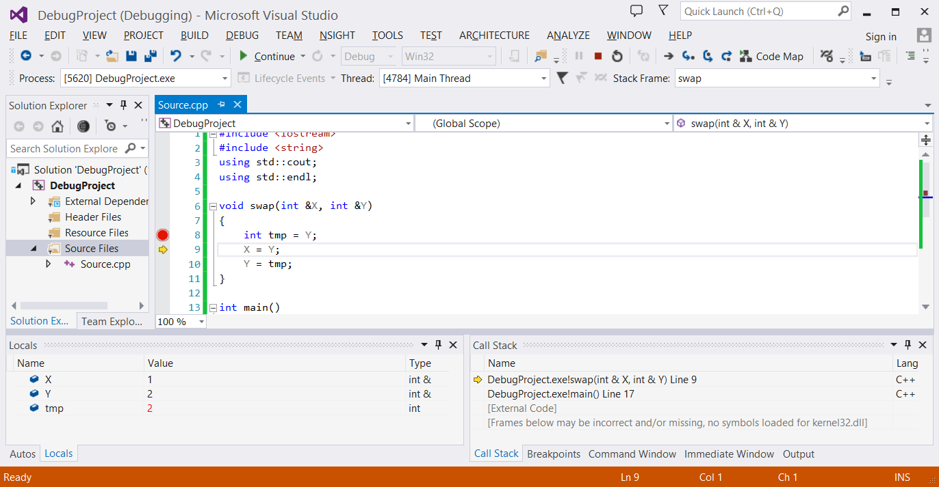

Variable **tmp** now has the value 2

Yellow arrow has now moved to the next line after the **Step Over**!

I am going to **Step Over** again to see what the next statement will produce.

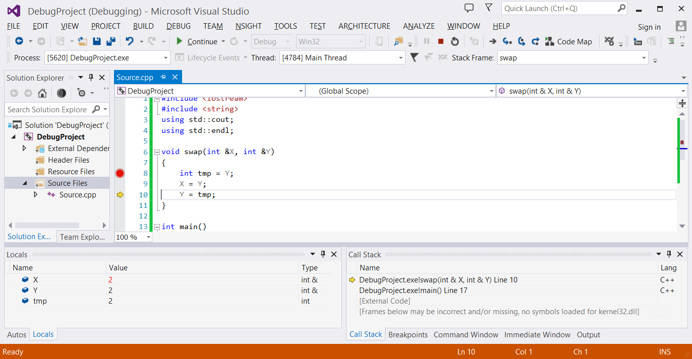

Variable **X** now has the value 2

Yellow arrow has now moved to line 10 after the **Step Over**!

Okay, I think I know where I went wrong now! I should have assigned **X** to **tmp**, and not **Y** to **tmp**, because the value of **X** is being overwritten without ever assigning its value to **Y** in the swap.

The fix is simple, so it is time to stop the debugging session by clicking on the **Stop Debugging** button.



Click **Stop Debugging**

I can now change the code of my swap function to:

void swap(int &X, int &Y)

{

int tmp = X;

X = Y;

Y = tmp;

}

Let’s us try this change out by running our program again, but this time without debugging.

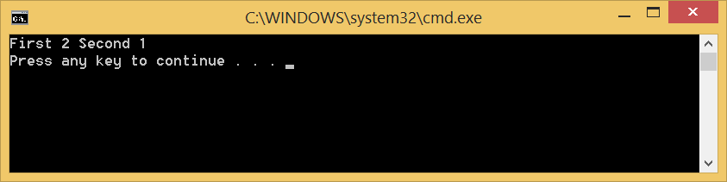

Yes I think this is a lot better!

Happy debugging CS-273!